 

|  |  |
| --- | --- |
| Teacher: Mrs. Evans | Grade: 7&8 |
| Course : Dance and Rubies Dance Team | Room #: C105 |
| Email:  bevans@dickinsonisd.org | Phone Number: (281) 309-3635 |
| Conference Time:  7:45am-8:38am | Website: www.dickinsonisd.org/page/fa.kjhs_da |

**Introduction:** The vision of Kranz Jr. High is, All students will learn. Every adult will do whatever is necessary to ensure all students learn.

Course Description: Students will be able to execute technical dance elements appropriate to class level and develop a greater appreciation of various forms of dance.

**Grade Breakdown:**

|  |  |
| --- | --- |
| Daily Work (dressing out and participation) | 45% |
| Tests, Projects and Major Assignments | 40% |
| Curriculum-Based Assessments | 10% |
| Homework | 5% |

Required Dance Attire (45% of grade)

1. KJHS Dance T-Shirt $13 must be ordered online. **Use the QR code below to purchase or visit:**

[**https://gogearup.io/kjh-dance22**](https://gogearup.io/kjh-dance22)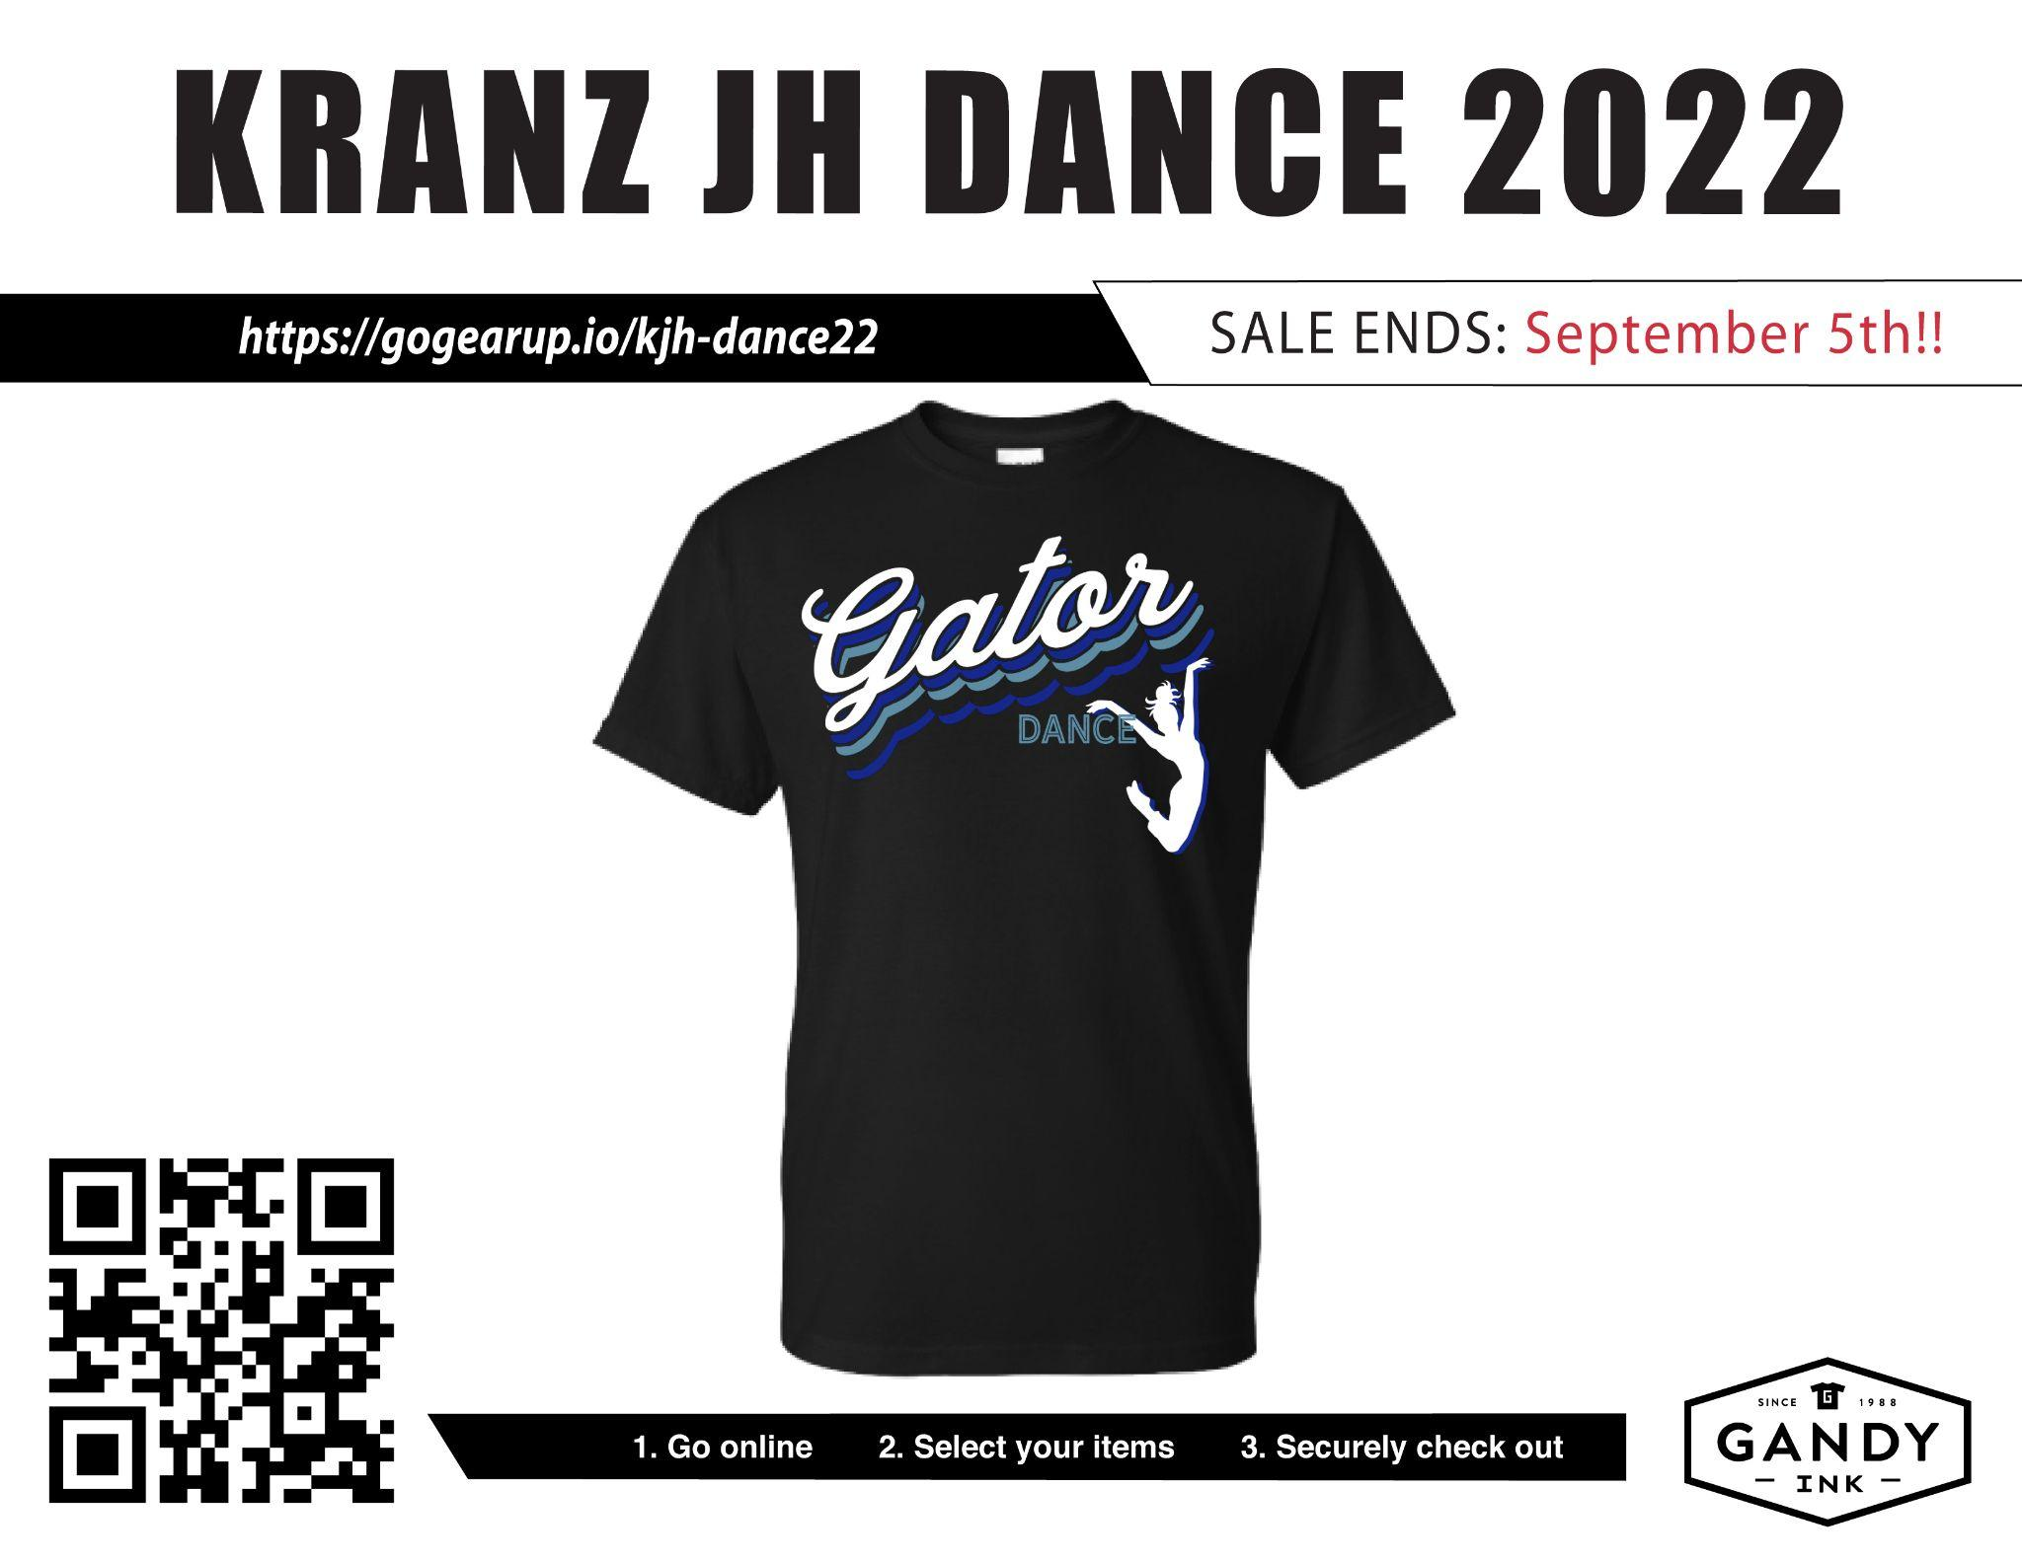

**Sale ends September 5th at midnight**

*I highly recommend purchasing more than one t-shirt!*

1. One pair of black or tan jazz shoes, or turners (purchase on your own)
2. Black dance pants such as capris, leggings, or long jazz pants (purchase on your own)

*#2 and #3 can be purchased at Backstage DanceWear, Amazon, Wal-Mart, Target, Dance Store, Academy, payless, and fitness departments.*

Grading System: A 100 points will be given each day (50 Dress out / 50 Participation)

1. Deduction Points

* -50 Not dressed out completely (ALL OR NOTHING)
* -10 Excessive talking/behavior
* -50 Failure to participate fully or failure to follow instructions
* -10 Hair not up

Absence Policy: Ask the director for missed assignments upon return and before class starts.

Academic Dishonesty Policy: Students caught being academically dishonest on assignments or tests, will receive a grade of ZERO and possible disciplinary action. Please refer to the Academic Dishonesty Policy handout for more details.

Late Work Policy: 10 points will be deducted each day off their grade after the given due date.

Discipline: The rules set forth in the KJHS student code of conduct will be enforced in this class.

**Dance Class Performance Finals and Department Fundraisers:**

Winter Showcase: December 6th, 2022 6:00-7:00pm

Student Choreography Spring Showcase: March 30th, 2023 6:00-7:00pm

*Showcases are in the KJHS Auditorium*

Tickets for each showcase will be $5.00 pre-sale online and at the door for $10.

Tickets will be sold 2 weeks prior to the show.

**Required Student and Teacher Communication**

**BAND App**

This app is designed for teachers and students to communicate, share documents, music, videos, pictures, votes, ask questions, and more. I use this quite often and post important information and reminders weekly. Students must join via phone or computer before

Use this QR code to join 

(or visit <https://band.us/n/acaa70D3e9EbZ>)



Parents and students, please sign below showing that you have read the syllabus and understand the expectations, rules and class procedures of all KJHS Dance.

Please print clearly.

_____________________________ _____________________________

Student signature Student Name (printed)

_____________________________ _____________________________

Parent signature Parent Name (printed)

_____________________________ _____________________________

Parent email Parent contact #

*Class Period

___________